Global Sport Academy
Fund Raising Program

Important Notes Regarding Fundraising:
Each team member is responsible for checking the guidelines for fundraising as they pertain to their eligibility with their respective athletic association. All personal (i.e. relatives or legal guardians) funds paid above and beyond the tour cost will be refunded in September of the year traveled. All non-personal funds (i.e. from donors) received above and beyond the tour cost become property of GSA (due to NCAA regulations) and will be allocated to the team fund as a means of tour enhancement.

Individual Fundraising Program:
If you plan to fundraise for your portion of the team’s expenses we have a very successful program for you. We recommend using the attached fundraising letter to raise your share of the expenses.

- Individual Target Marketing Planning
- Make a list of possible donors (200-250 contacts)
- Family Members- grandparents, aunts, uncles, etc.
- Family Friends and Neighbors
- Professional Acquaintances- doctors, insurance agent, barber/hair dresser, auto mechanic, car dealer, local businesses, etc.
- Corporate Sponsors- Check with the human resources department where you and your family work- some companies have funds available for programs like this or they have may have matching programs to help.
- Clubs and Professional Organizations at School and Home- Eagles Lodge, VFW, Masons, Lions Club, American Legion, Church Group, etc…

- Delivering the Fundraising Letter
- Hand-Deliver Fundraising Letter - The most successful approach we have seen is if you hand deliver the fundraising letters to those you can, you will see a success rate of nearly 100%. We like to think of it as the “Girl Scout” approach- if you are in front of them it is much harder to be turned down.
- Mailing Fundraising Letter - Send a self-addressed stamped envelope along with the donation form and a cover letter telling about yourself and the opportunity for you to compete on the International level and represent the USA. Over the next 2 weeks, follow up with them about their donation.

- Receive
Have your donations mailed directly to GSA. Over time, you will see that even small donations of $10-$20 will make up the bulk of your goal. Therefore, the more letters you send out, the better chance you have to reach your fund raising goal. For example: 100 donations of $20 = $2000.

Do not mail this page with the attached letter

Dear ____________________

I am writing to you because I have been honored to have been invited to join the Global Sports Select/All Star Team, which will train, compete, and tour internationally. With this opportunity I shall act as an ambassador representing the United States and my respective institution, while competing internationally. The team as a whole will spend some time exploring the local region and discovering the customs/traditions of another culture while gaining an educational experience too. You can find out more information regarding this tour by going to http://www.globalsportsacademyus.com/Travel_.html

In order for this trip to be a success, I have to cover my portion of the team’s expenses. Any donation you can give would go directly towards the team’s expenses, and would be greatly appreciated. Global Sports Academy would also like to thank everyone for your contributions and support. We will do our utmost to show good sportsmanship and represent the USA with class and distinction.

Thank you in advance for your support.
Sincerely,

Student Name: ________________________

School Name: _________________________

Donation Information

Donation From: __________________________________________

Donor’s Address:
______________________________________________________________________________
[Street] [City] [State] [Zip]

Amount: $_______________
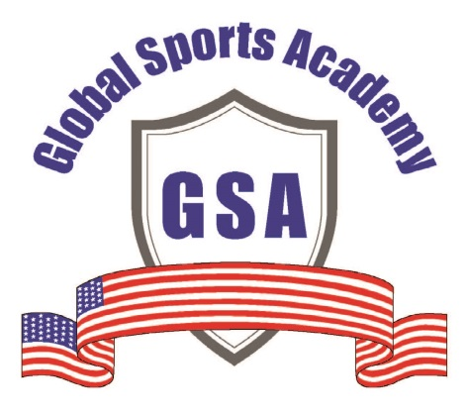

Please mail your donation directly to the address below:

Global Sports Academy
Attn; Roy Blumenthal
701 Andover Court
West Chester, Pa 19382
Make Checks Payable to Global Sports Academy

